Test Case 1 – OrangeHRM Login Page
Test Case ID: WB01
Test Case: Verify OrangeHRM login page is displayed
Test Steps: Open the OrangeHRM login page in the browser.
Expected Result: OrangeHRM login page should be displayed with Username, Password and Login fields.
Actual Result: OrangeHRM login page was displayed successfully with Username, Password and Login fields.
Status: PASS
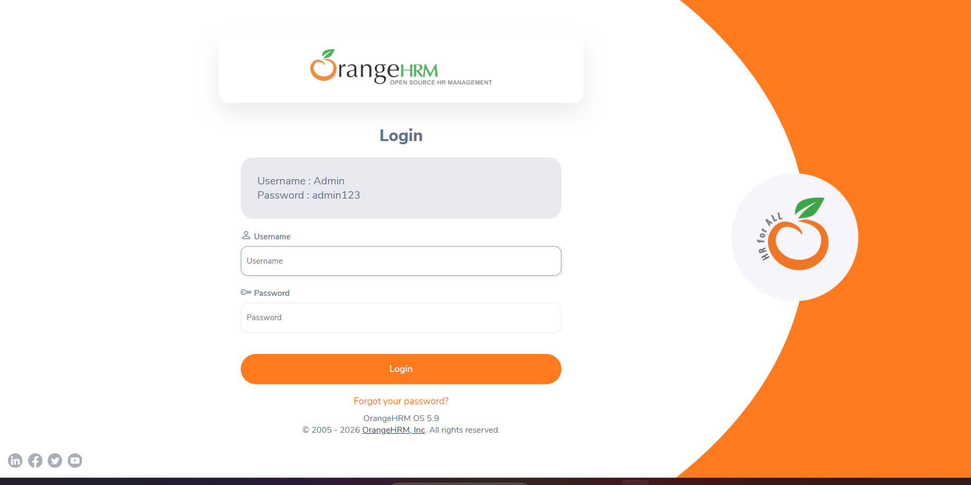

Test Case 2 – White-Box Source Code
Test Case ID: WB02
Test Case: Verify login logic is implemented using conditional statements
Test Steps: Open the whitebox.py file in Visual Studio Code and review the login function and conditional branches.
Expected Result: Login logic should contain a condition for valid credentials and separate True and False execution branches.
Actual Result: Login function with valid and invalid credential conditions was implemented successfully.
Status: PASS
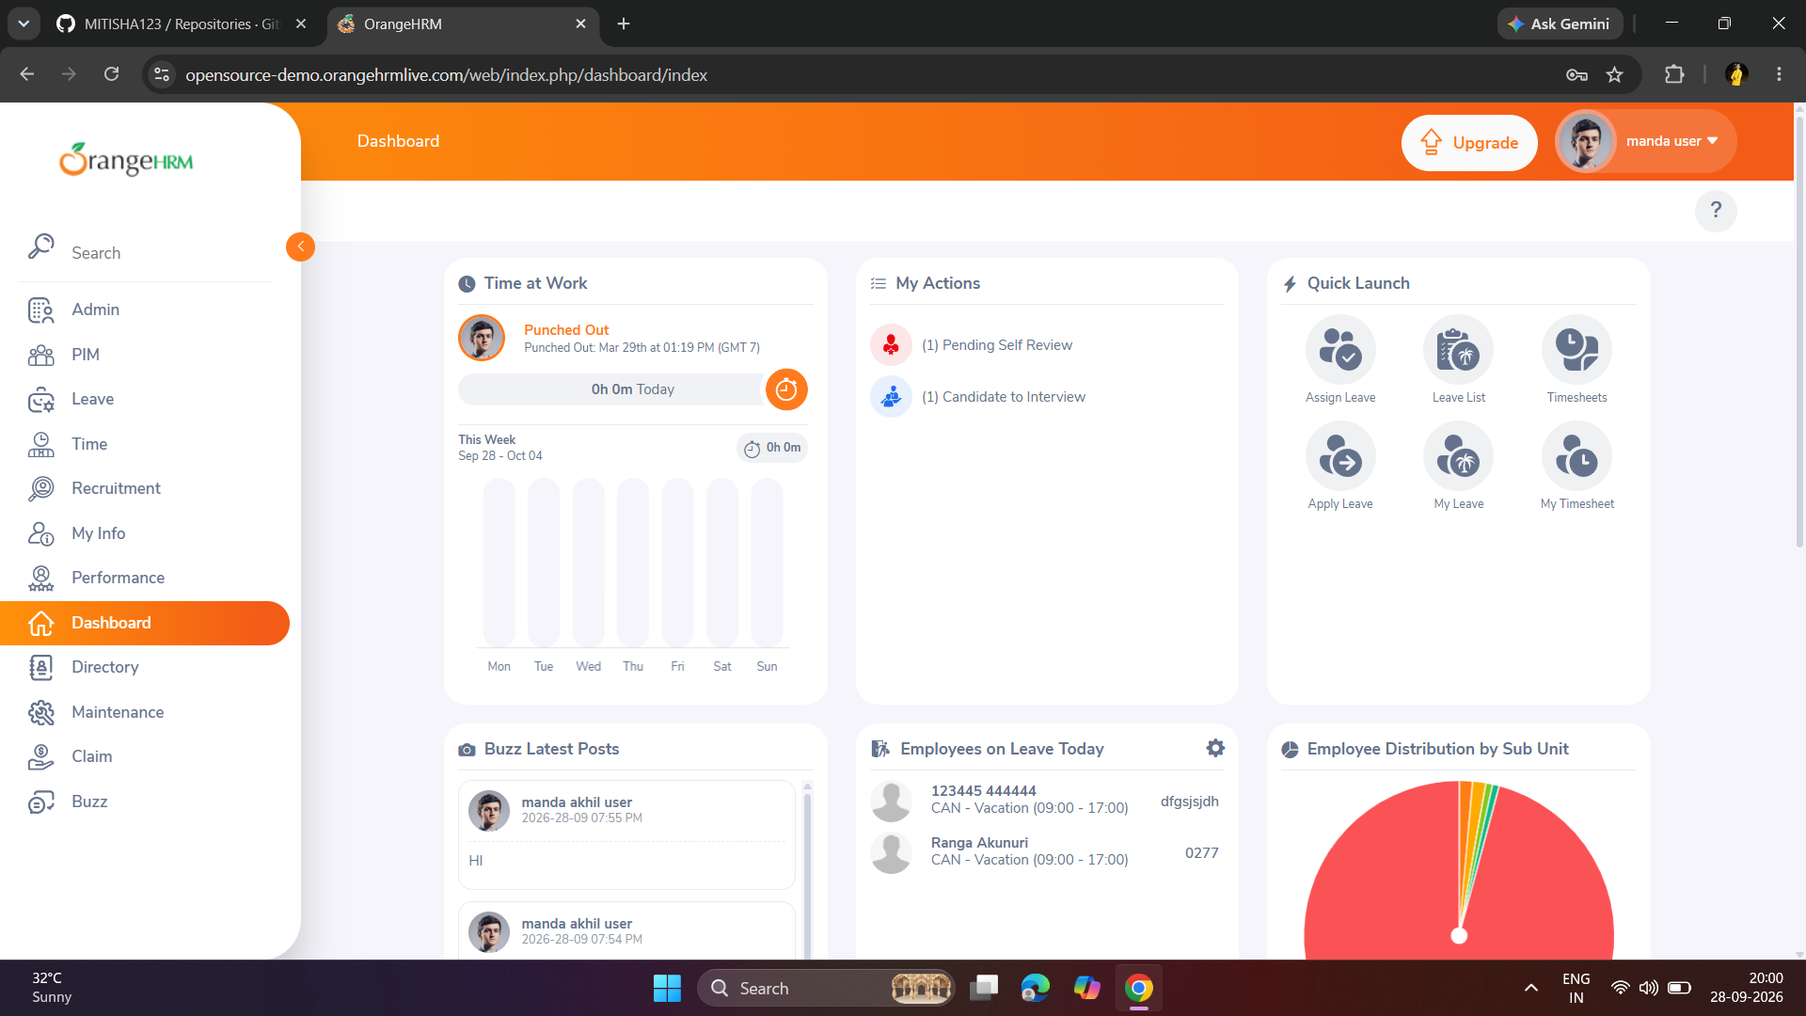

Test Case 3 – Valid Login
Test Case ID: WB03
Test Case: Verify login with valid username and password
Test Steps: Enter valid username admin and password admin123, then click the Login button.
Expected Result: User should be logged in successfully and the Dashboard should open.
Actual Result: User logged in successfully and the OrangeHRM Dashboard was opened.
Status: PASS
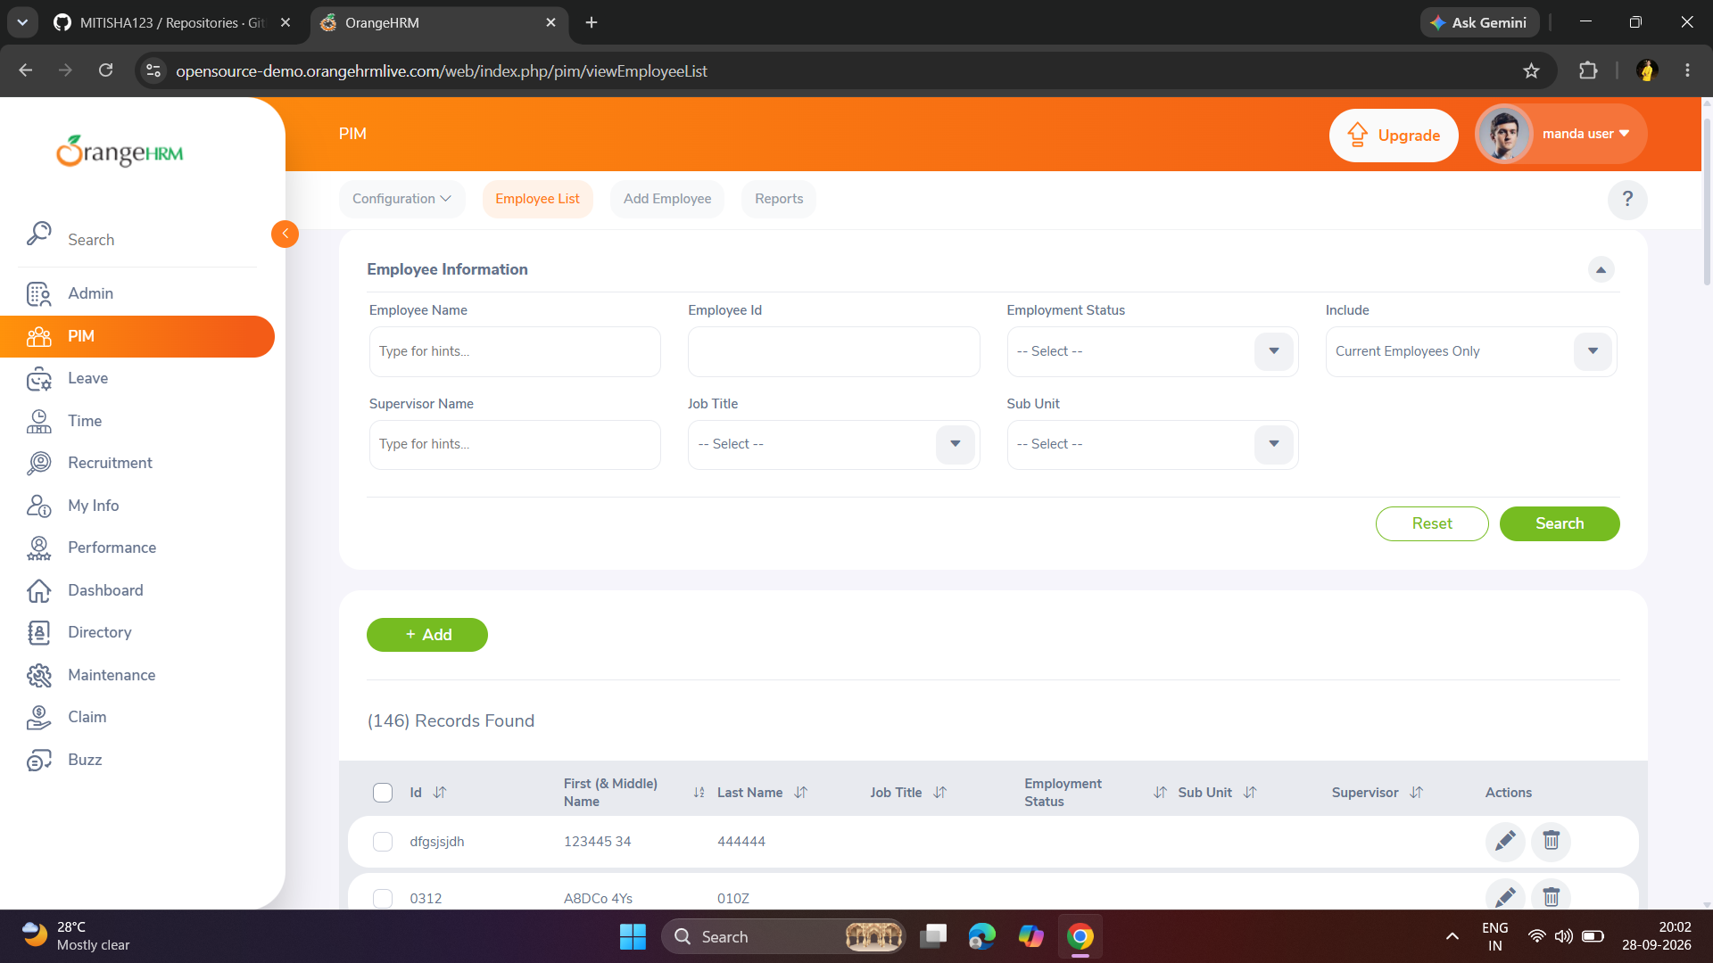

Test Case 4 – Invalid Login
Test Case ID: WB04
Test Case: Verify login with invalid password
Test Steps: Enter username admin and an incorrect password, then click the Login button.
Expected Result: System should display an invalid credentials message.
Actual Result: Invalid credentials message was displayed successfully.
Status: PASS
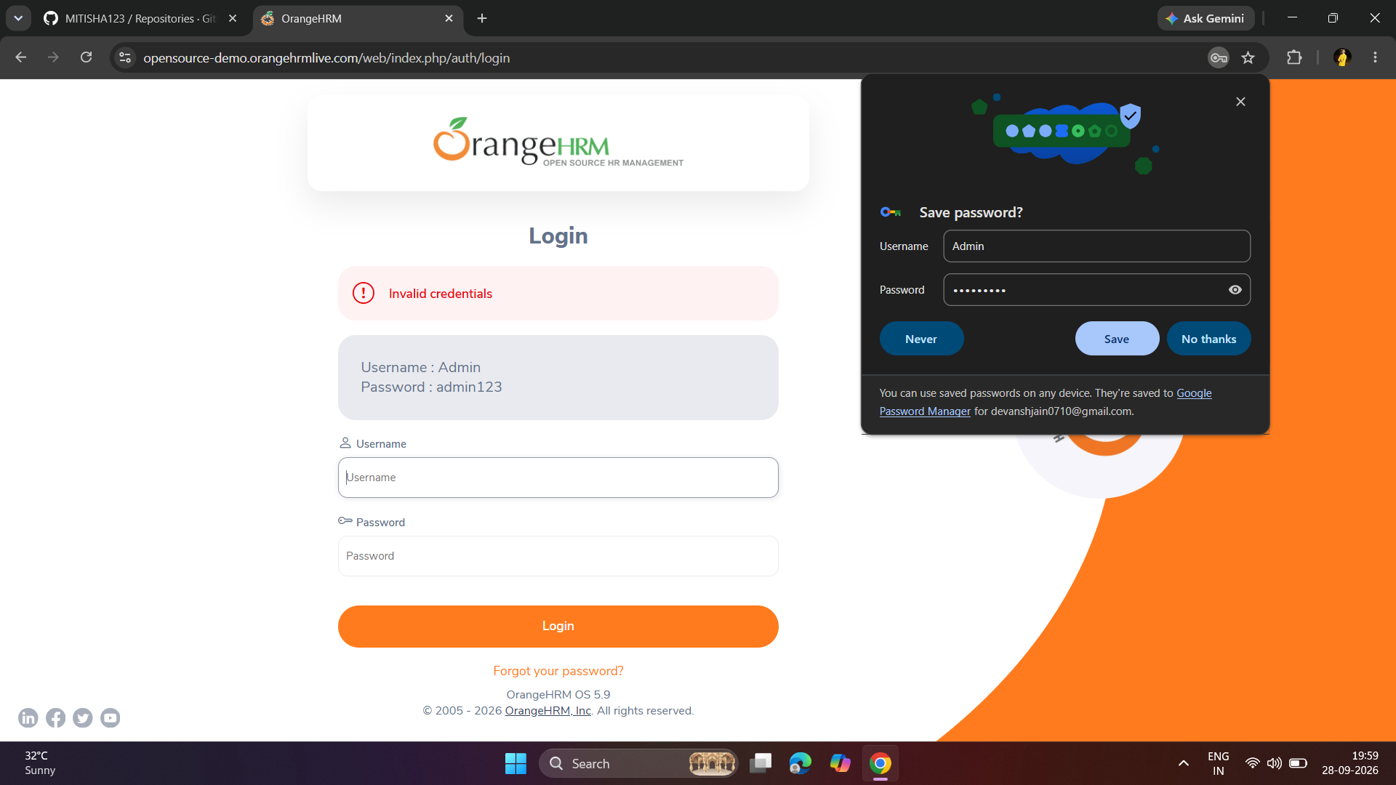

Test Case 5 – Python Program Execution
Test Case ID: WB05
Test Case: Verify both valid and invalid login branches are executed
Test Steps: Run the whitebox.py program in Visual Studio Code.
Expected Result: Program should execute both valid-login and invalid-login branches and display their respective outputs.
Actual Result: The program successfully displayed Login Successful / Dashboard Opened for the valid branch and Invalid Username or Password for the invalid branch.
Status: PASS
